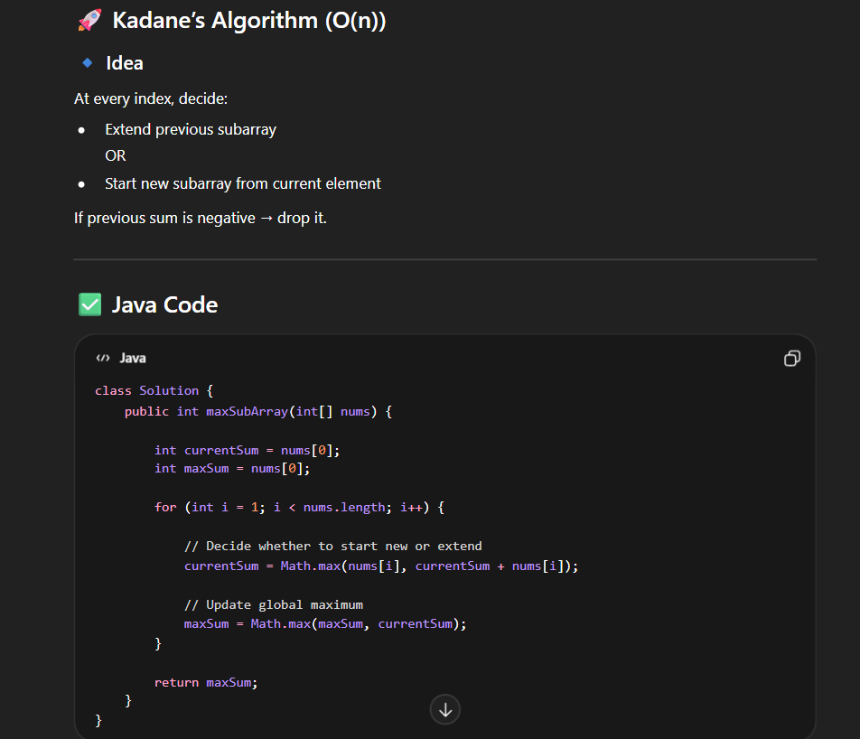

BRUTE FORCE:
import java.util.*;
class Solution {
public int maxSubArray(int[] nums) {
int maxi = Integer.MIN_VALUE;

for (int i = 0; i < nums.length; i++) {
int sum = 0;

// Iterate over each ending index of subarrays starting from i
for (int j = i; j < nums.length; j++) {

// Add current element to sum
sum += nums[j];

maxi = Math.max(maxi, sum);
}
}
return maxi;
}
}
public class Main {

public static void main(String[] args) {

int[] arr = { -2, 1, -3, 4, -1, 2, 1, -5, 4 };
Solution sol = new Solution();
int maxSum = sol.maxSubArray(arr);
System.out.println("The maximum subarray sum is: " + maxSum);
}
}

HOW ITS SOLVED :

First initialize the currentsum and maxsum as first elemnt in array
Then iterate over the array .compute the sum for each iteration if the sum because negative then drop the sum and start new .

https://leetcode.com/problems/maximum-subarray/?envType=problem-list-v2&envId=array

